CSA 283: Exam One

Name: ______________________________________ Section: _____ _____

Please write legibly. Ask questions if something is unclear. Be concise in written answers.

You may use the Java 2 Platform Std. Ed. 6.0 documentation at http://java.sun.com/javase/6/docs/api/. You may not use any other documentation or notes.

Some useful formulas:
d_{trans} = L/R d_{prop} = d/s

L – packet length, R – link bandwidth, d – distance, s – propagation speed

Questions:

- List the five protocol layers of the internet in order from highest to lowest. (5 points)

________________

________________

________________

________________

________________

- List the transport layer protocol used by the following application layer protocols. State whether they use a client/server or peer-to-peer network architecture. (8 points)

Transport Protocol Architecture

HTTP: _________________ _________________

SMTP: _________________ _________________

DNS: _________________ _________________

FTP: _________________ _________________

- List two primary advantages of circuit switching as compared to packet switching. (4 points)

________________________________________________

________________________________________________
- Give definitions for the following terms using one or two sentences. If the term is an acronym, also state what the letters in the acronym stand for and give a definition.
(10 points)

a. RFC:

b. Elastic Application:

c. Connectionless Unreliable Service:

d. Traffic Intensity:

e. Queuing Delay:

- Describe how conditional get requests might be used by an institutional web cache (proxy server). (4 points)

To send a conditional GET message, a request message has to contain GET method and include an If-Modified-Since: header line. The proxy server can use conditional get requests to check if an object is up to date. If the object is not modified since the specified date, the web server will not send new copy of object back to proxy server, it will only send a response code to proxy server.

- Describe how content is found in a query flooding peer-to-peer file sharing system. What mechanism is used to keep queries from being sent to every peer in the network? (4 points)

- Consider the following scenario:

You are designing a client/server application in which clients intermittently upload data to a server for storage. The server saves the data for use by an application that only runs once per week to produce a summary (assume the application runs on the same machine as the server). The application must have a complete set of all data in order to generate the summary. Which transport layer protocol would you use to support this application? Why? (4 points)

- List three reasons DNS uses a distributed database instead a centralized database.
(6 points)

________________

________________

________________

- Use the constants below to answer the following questions. Show work for partial credit. Indicate the units for each answer. Show times to four decimal places. Assuming processing and queuing delays are negligible.

File Size 35 Mb
Packet Size 1.5 Mb
Link Bandwidth 20 Mbs
Link Lengths 40 Kilometers
Propagation Speed 2.8 x 10⁵ Kms

- Calculate the propagation delay for a single link. (2 points)

b. Calculate the transmission delay for a single packet and a single router.
(2 points)

- Assuming there are seven links connected by routers as depicted below. If processing and queuing delays are negligible, how much time will be required for a single packet to travel from A to B. (3 points)
A
B

d. Again assume and queuing delays are negligible. For pipelined transmission with a transmission window of infinite size (A continuously transmits packets as fast as possible), calculate the time needed for the entire file to travel from A to B. (6 points)

- Consider the following scenario:

A host running on joe.uc.edu wants to transmit email for Oscar.npr.org. In the following, assume that all nodes including joe.uc.edu cache DNS records. All DNS caches are initially empty. The first query sent by joe.uc.edu is handled recursively. Assume all other queries are handled iteratively. DNS server names are as follows:

TLD DNS server, edu: dns.tld.edu
TLD DNS server, org: dns.tld.org
Local DNS server, uc: local.uc.edu
Local DNS server, npr: local.npr.org
Authoritative DNS, npr: dns.npr.org
Authoritative DNS, uc: dns.uc.edu
Root DNS server: dns.root

- 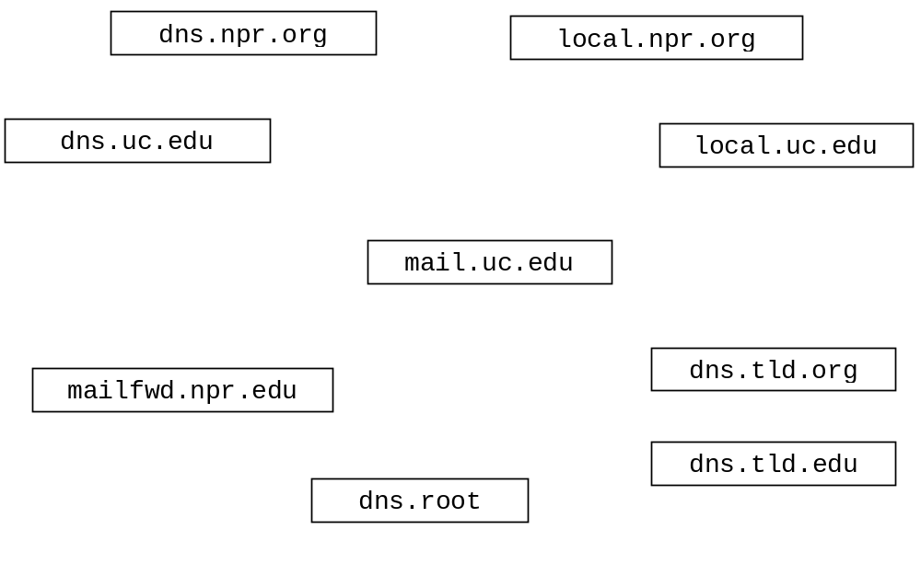Draw arrows labeled with numbers to indicate the order of queries and responses sent before joe.uc.edu receives the IP address of oscar.npr.org. (8 points)
- After the sequence in part a. has occurred, suppose mary.uc.edu wants to upload mail for jerry.npr.org. How would the sequence of events be different?
(3 points)

- What type of resource record would actually contain the IP address of jerry.muohio.edu mail? (circle one) (2 points)

Type A Type NS Type CNAME Type MX

- Consider the following scenario:

An email message is sent from frank@bar.com to lisa@contra.edu. The following three transfers of the message are performed.

Transfer One: An outlook email application running on 134.53.101.22 uploads the message to the mail server mail.foo.bar.com.

Transfer Two: mail.foo.bar.com contacts a mail server called po.contra.edu and uploads the message to po.contra.edu

Transfer Three: Eudora running on 123.99.200.14 is used to download the message from po.contra.edu .

For each of the transfers, name the application layer protocol that would normally be used. Specify which machine it the client and which is the server during the transfer (9 points)

Transfer One: Protocol: ______________

Client: ______________

Server: ______________

Transfer Two: Protocol: ______________

Client: ______________

Server: ______________

Transfer Three: Protocol: ______________

Client: ______________

Server: ______________

- Complete the Server class below. Do not worry about handling exceptions. Allow the main method to throw all exceptions to the OS. (28 points)
(You may write your code on the back of a page.)
- Clients send the Server two floats in a single packet using UDP. The first float is a base. The second number is an exponent.
- The server prints out the IP address and the port number the socket the client used to send the floats
- The Server raises the base to the exponent and sends this result back to the client as a double using UDP.
- When the result is less than one, the server will return it and then close down. Otherwise the server will continue to run and service other clients.
- The Server listens for clients on port number 9999.
- The Server handles clients sequentially.

import java.io.*;
import java.net.*;
public class UDPPowerServer {

public static void main(String[] args) throws Exception
{

- Complete the client class below. Do not worry about handling exceptions. Allow the main method to throw all exceptions to the OS. (16 points)
(You may write your code on the back of a page.)
- Write a client program that reads in a two floats from the console. The first number is a base and the second is an exponent.
- The client program sends the numbers as floats to a server using TCP.
- After sending the floats, the base raised to the power of the exponent is received via TCP from the server as a single float and displayed to the console.
- The program should close after handling a single line of numbers.
- The server is at 131.1.22.6 and port number 9999.

import java.io.*;
import java.net.*;
public class TCPPowerClient {

public static void main(String[] args) throws Exception
{
Scanner scan = new Scanner( new InputStreamReader( System.in ));
System.out.print("Enter a base: ");
float base = scan.nextFloat();
System.out.print("Enter an exponent: ");
float exponent = scan.nextFloat();

